Technical University of Cluj-Napoca

Faculty of Automation and Computer Science

**Project:**

DC STABILIZED SWITCHED MODE POWER SUPPLY

C.

The Controllers design

2023-2024

**C.1. Controller design**

For the project we had to use two different kinds of controllers:

* **Proportional**
* **Proportional-Integral**

The transfer function of the fixed part:

$$H_{f}\left(s\right)=\frac{1}{2A}∙\sqrt{2}∙k_{u}∙{\tilde{U}}_{2}∙\frac{1}{LCs^{2}+\frac{L}{R_{s}}s+1} = \frac{0.6894}{ 6.49∙{10}^{-7}∙s^{2} + 0.002596 s + 1}$$

**C.1.1 Proportional Controller Design**

Because $H_{f}$ has two real negative a P controller will not ensure a steady state error $ε_{ss}=0$.

We will impose the following performance characteristic for the overshoot $σ:$

$$σ=10\%$$

We can use the root locus of the fixed transfer function to tune our controller:

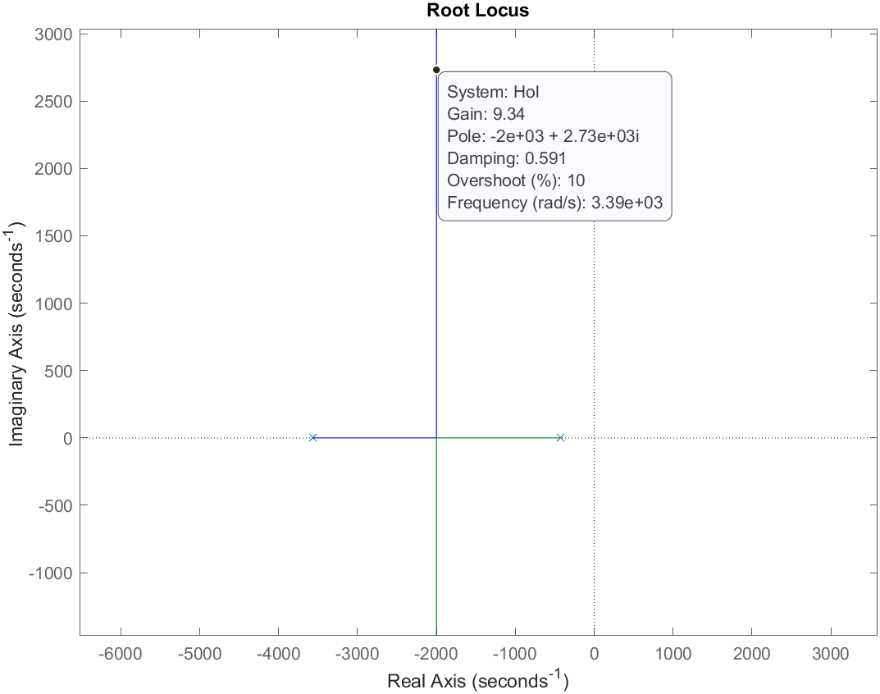

Therefore the value for $kp=9.34$

**C.1.2 Proportional-Integral Controller Design**

We will impose the following performance characteristic for the overshoot $σ:$

$$σ=10\%$$

The controller transfer function will be:

$$H_{c}\left(s\right)=k_{p}∙\frac{1+T_{i}∙s}{T_{i}∙s}$$

We will take $T_{i}=1/{432}$ witch is the dominant time constant in our process and we will cancel it.

We can again use the root locus of the fixed transfer function to tune our controller:

Therefore the value for $kp=4.06$ and $T_{i}=1/{432}$.

Technical University of Cluj-Napoca

Faculty of Automation and Computer Science

**Project:**

DC STABILIZED SWITCHED MODE POWER SUPPLY

D.

The simulation of the stabilized DC power supply

2023-2024

**D.1. Step response**

**D.1.1 Step response on the P controller:**

We have the following simplified mathematical model of the DC power supply:

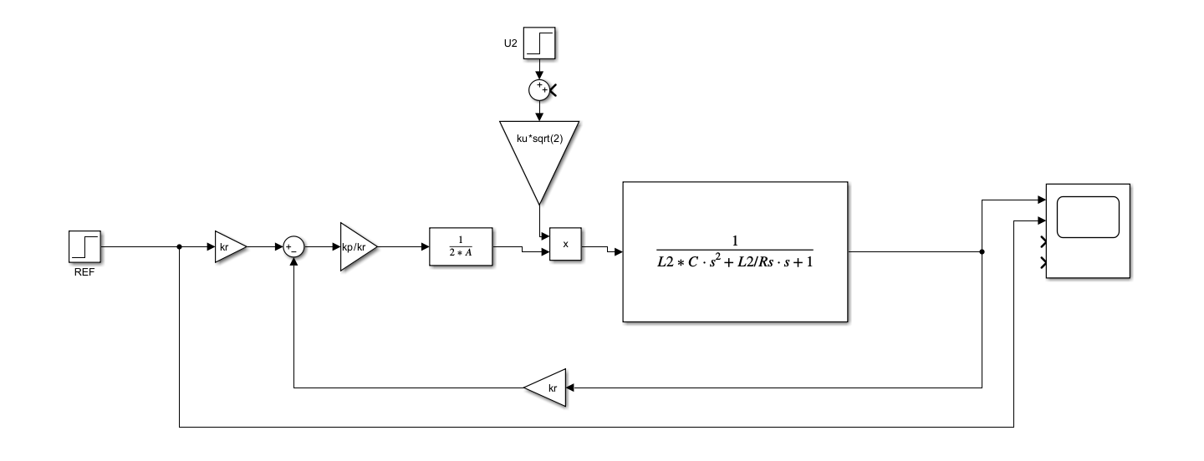

The reference will be: $V_{0}^{*}=11.03V$ thus giving the following simulation:

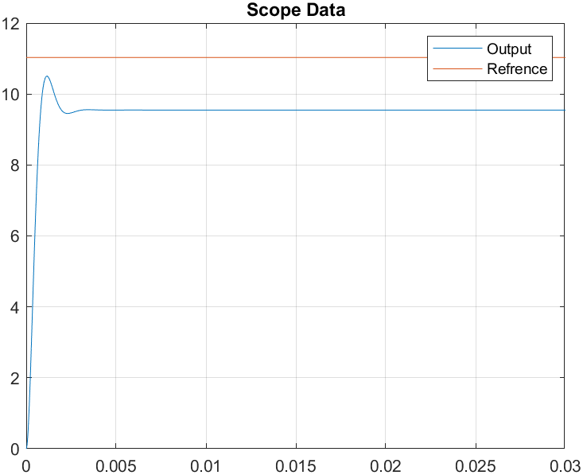

The output has an overshoot of: $σ=10\%$ and a steady state error of: $ε_{ssp}=15,71\%$.

**D.1.2 Step response on the PI controller:**

The simplified mathematical model of the DC power supply is:

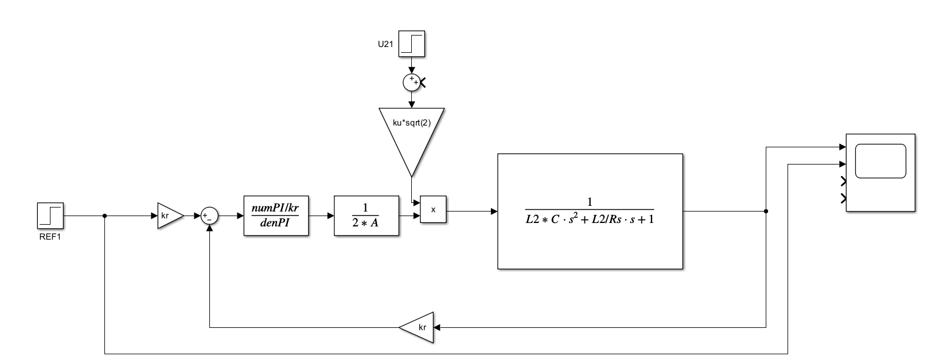

With the same reference voltage as before we have the following response:

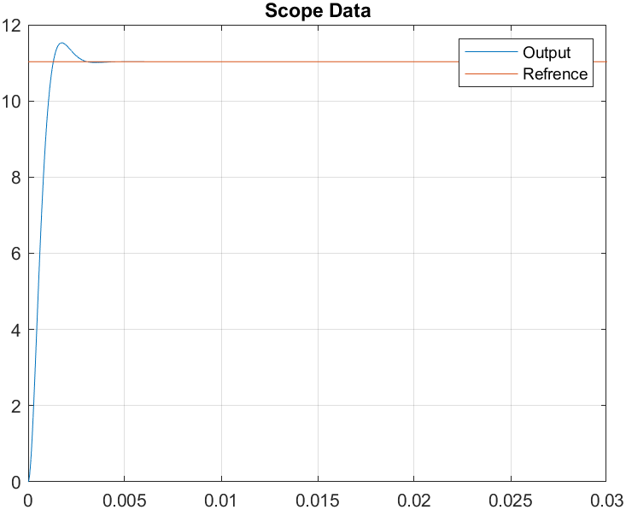

We see that the overshoot is no more than $σ=10\%$ and the steady state error $ε_{ssp}=0$.

**D.2. Step response with disturbance to the input**

**D.2.1 Input disturbance on the P controller:**

I added a perturbation of $10\%∙U2 \left[V\right]$ at the moment in time 0.005 seconds.

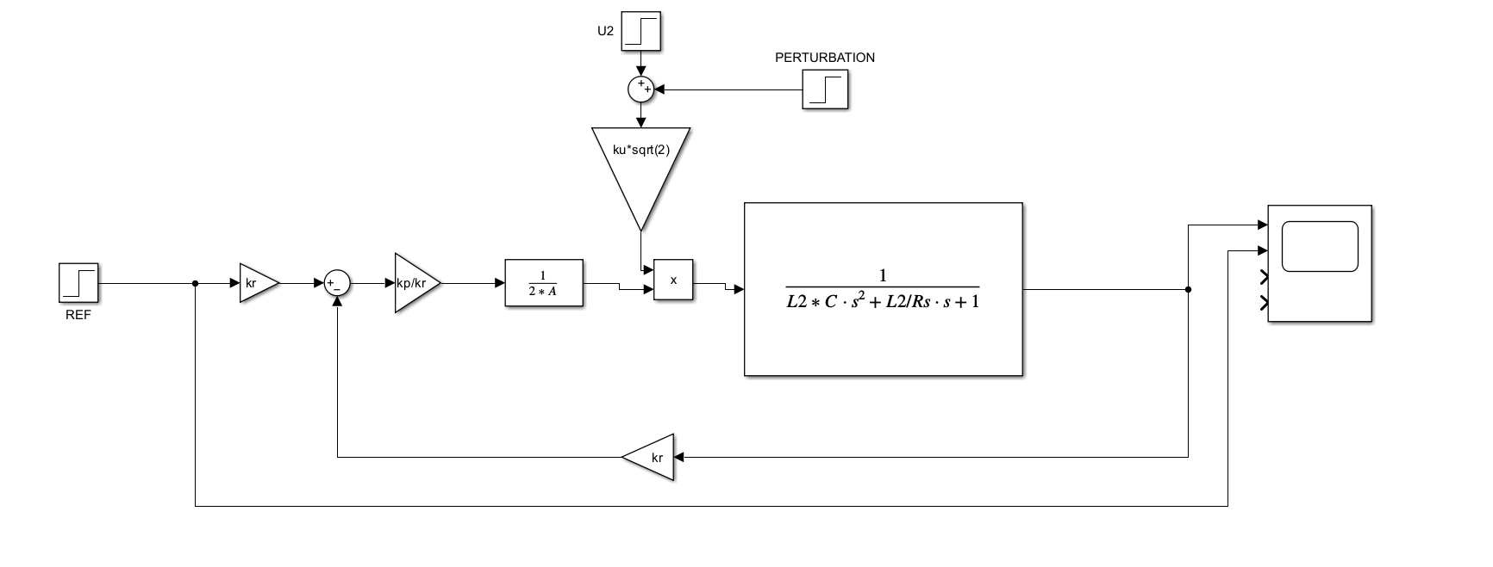

And this is the result of the simulation:

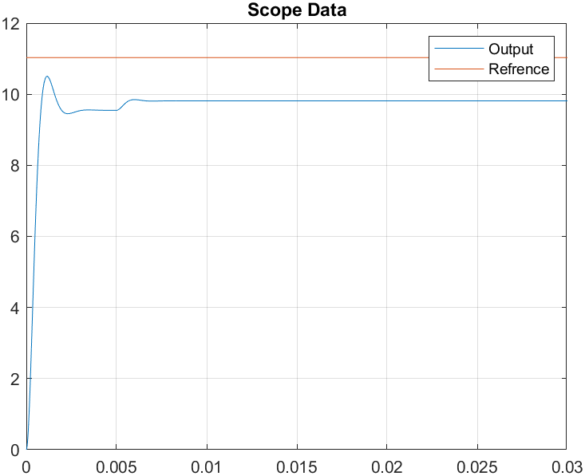

**D.2.2 Input disturbance on the PI controller:**

I added a perturbation of $-10\%∙U2 \left[V\right]$ at the moment in time 0.015 seconds.

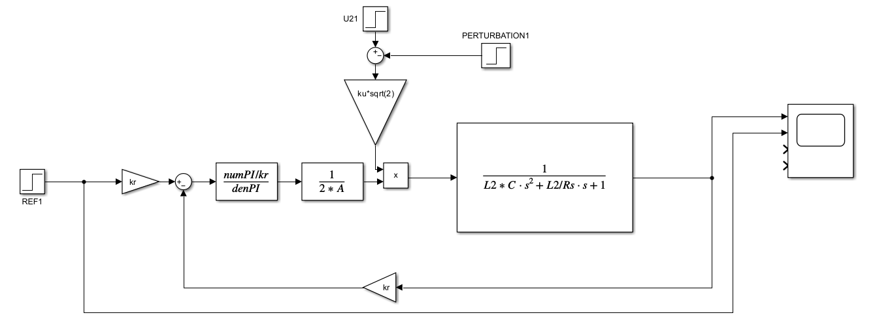

And this is the result of the simulation:

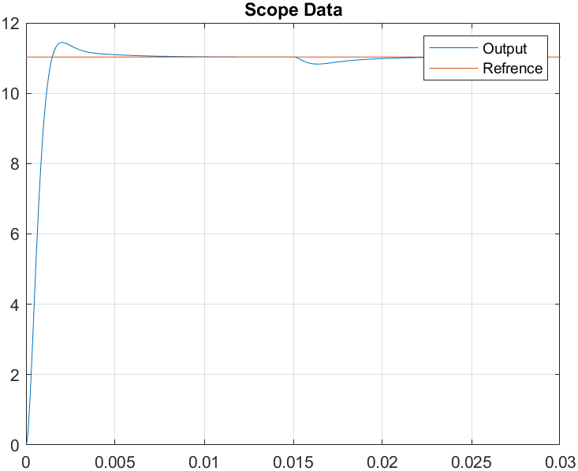

**D.3. Step response with disturbance to the output**

**D.3.1 Output disturbance on the P controller:**

I added a perturbation of $-20\%∙Rs$ at the moment in time 0.012 seconds.

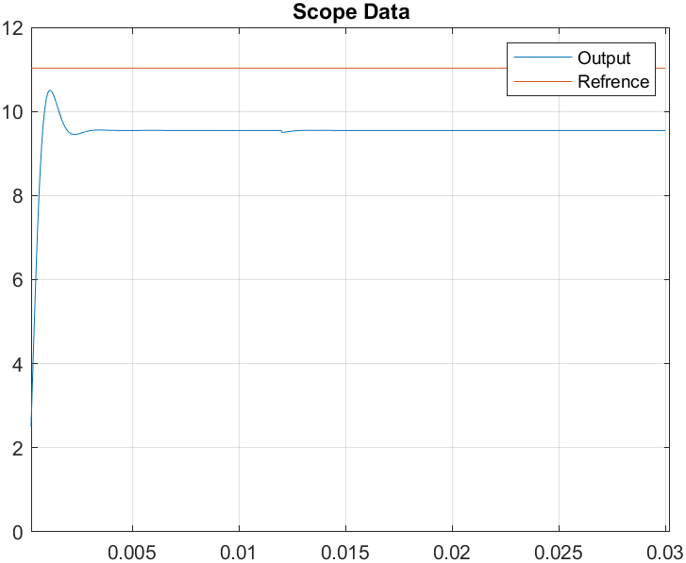

**D.3.2 Output disturbance on the PI controller:**

I added a perturbation of at the moment in time 0.012 seconds.

